### **Project 02 - 1 Hour**

### **Comprehensive Deployment of a Multi-Tier Application with CI/CD Pipeline**

### **Objective:**

Deploy a multi-tier application (frontend, backend, and database) using Docker Swarm and Kubernetes, ensuring data persistence using a single shared volume across multiple containers, and automating the entire process using advanced shell scripting and CI/CD pipelines.

### **Overview:**

1. **Step 1**: Set up Docker Swarm and create a multi-tier service.
2. **Step 2**: Set up Kubernetes using Minikube.
3. **Step 3**: Deploy a multi-tier application using Docker Compose.
4. **Step 4**: Use a single shared volume across multiple containers.
5. **Step 5**: Automate the deployment process using advanced shell scripting.

### **Step 1: Set up Docker Swarm and Create a Multi-Tier Service**

#### **1.1 Initialize Docker Swarm**

# Initialize Docker Swarm

docker swarm init

docker swarm init --advertise-addr 2402:a00:402:60d5:cbc4:ba92:e01a:5163

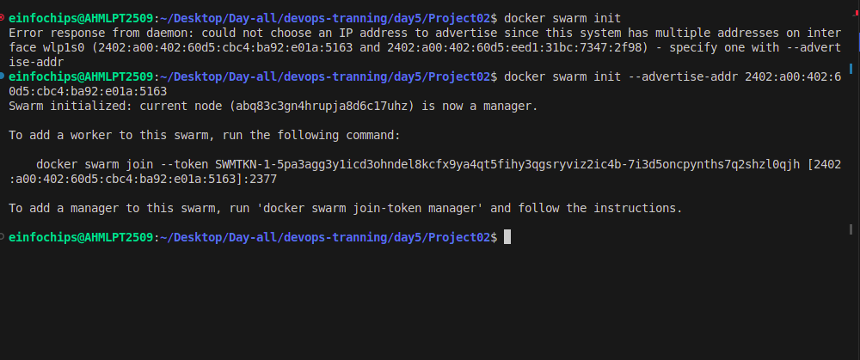

**1.2 Create a Multi-Tier Docker Swarm Service**

Create a docker-compose-swarm.yml file:

version: '3.7'

services:

frontend:

image: nginx

ports:

- "8080:80"

deploy:

replicas: 2

volumes:

- shareddata:/usr/share/nginx/html

backend:

image: mybackendimage

ports:

- "8081:80"

deploy:

replicas: 2

volumes:

- shareddata:/app/data

db:

image: postgres

environment:

POSTGRES_DB: mydb

POSTGRES_USER: user

POSTGRES_PASSWORD: password

deploy:

replicas: 1

volumes:

- dbdata:/var/lib/postgresql/data

volumes:

shareddata:

dbdata:

Deploy the stack:

# Deploy the stack using Docker Swarm

docker stack deploy -c docker-compose-swarm.yml myapp

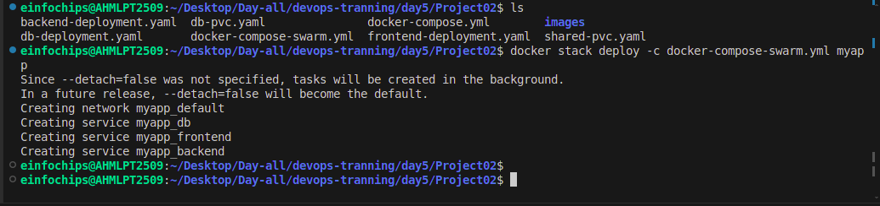

### **Step 2: Set up Kubernetes Using Minikube**

#### **2.1 Start Minikube**

# Start Minikube

minikube start

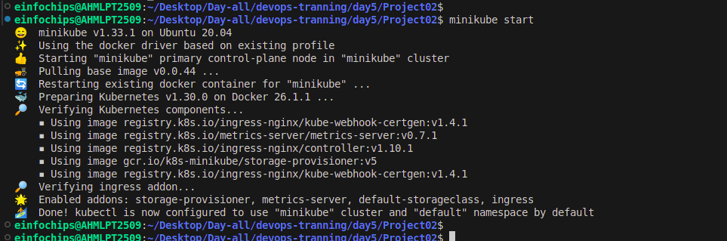

**2.2 check docker services**

docker service ls

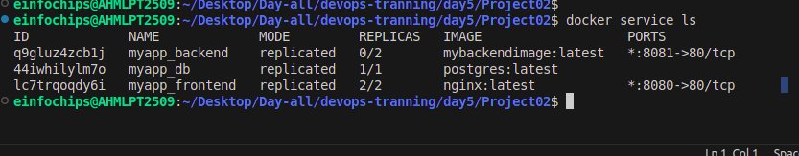

#### **2.3 Create Kubernetes Deployment Files**

Create frontend-deployment.yaml:

apiVersion: apps/v1

kind: Deployment

metadata:

name: frontend

spec:

replicas: 2

selector:

matchLabels:

app: frontend

template:

metadata:

labels:

app: frontend

spec:

containers:

- name: frontend

image: nginx

ports:

- containerPort: 80

volumeMounts:

- name: shareddata

mountPath: /usr/share/nginx/html

volumes:

- name: shareddata

persistentVolumeClaim:

claimName: shared-pvc

Create backend-deployment.yaml:

apiVersion: apps/v1

kind: Deployment

metadata:

name: backend

spec:

replicas: 2

selector:

matchLabels:

app: backend

template:

metadata:

labels:

app: backend

spec:

containers:

- name: backend

image: mybackendimage

ports:

- containerPort: 80

volumeMounts:

- name: shareddata

mountPath: /app/data

volumes:

- name: shareddata

persistentVolumeClaim:

claimName: shared-pvc

Create db-deployment.yaml:

apiVersion: apps/v1

kind: Deployment

metadata:

name: db

spec:

replicas: 1

selector:

matchLabels:

app: db

template:

metadata:

labels:

app: db

spec:

containers:

- name: db

image: postgres

env:

- name: POSTGRES_DB

value: mydb

- name: POSTGRES_USER

value: user

- name: POSTGRES_PASSWORD

value: password

volumeMounts:

- name: dbdata

mountPath: /var/lib/postgresql/data

volumes:

- name: dbdata

persistentVolumeClaim:

claimName: db-pvc

Create shared-pvc.yaml:

apiVersion: v1

kind: PersistentVolumeClaim

metadata:

name: shared-pvc

spec:

accessModes:

- ReadWriteMany

resources:

requests:

storage: 1Gi

Create db-pvc.yaml:

apiVersion: v1

kind: PersistentVolumeClaim

metadata:

name: db-pvc

spec:

accessModes:

- ReadWriteOnce

resources:

requests:

storage: 1Gi

Apply the deployments:

kubectl apply -f shared-pvc.yaml

kubectl apply -f db-pvc.yaml

kubectl apply -f frontend-deployment.yaml

kubectl apply -f backend-deployment.yaml

kubectl apply -f db-deployment.yaml

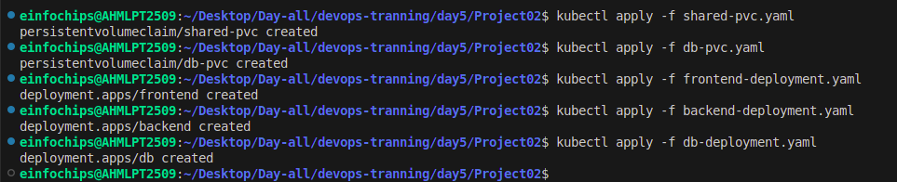

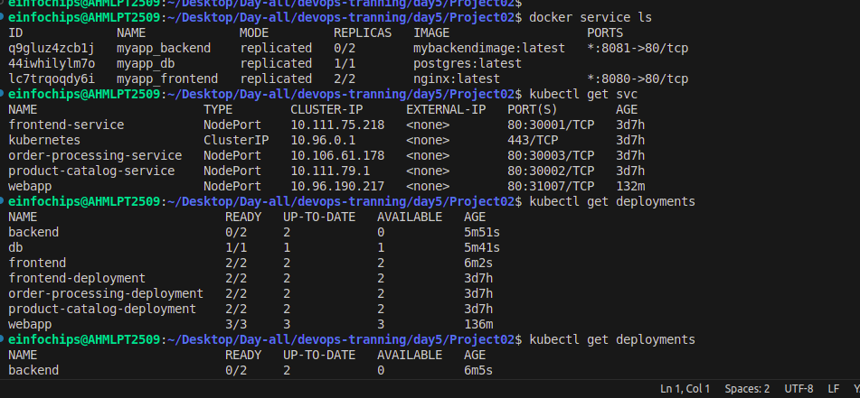

### **Step 3: Deploy a Multi-Tier Application Using Docker Compose**

#### **3.1 Create a docker-compose.yml File**

version: '3'

services:

frontend:

image: nginx

ports:

- "8080:80"

volumes:

- shareddata:/usr/share/nginx/html

backend:

image: mybackendimage

ports:

- "8081:80"

volumes:

- shareddata:/app/data

db:

image: postgres

environment:

POSTGRES_DB: mydb

POSTGRES_USER: user

POSTGRES_PASSWORD: password

volumes:

- dbdata:/var/lib/postgresql/data

volumes:

shareddata:

dbdata:

#### **3.2 Deploy the Application**

# Deploy using Docker Compose

docker-compose up –d

docker stack deploy --compose-file docker-compose.yml myapp

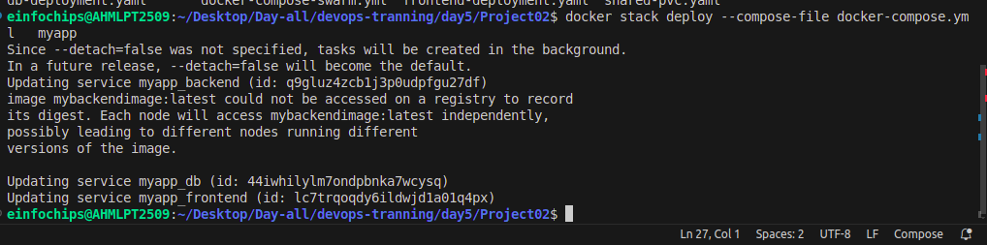

### **Step 4: Use a Single Shared Volume Across Multiple Containers**

Update docker-compose.yml as shown in Step 3.1 to use the shareddata volume across the frontend and backend services.

